

**A**

# Project Report On

**“E-Farming Portal” Submitted to**

**The Department Of Computer Studies**

**SIBER, Kolhapur**

**(An Autonomous Institute)**

**FOR THE PARTIAL FULFILLMENT OF MASTER OF COMPUTER APPLICATION**

# (MCA - I) (SEM – II) By

**Miss. Patil Rutuja ashok**

**Miss. Patil Urmila Uttam**

## Under the guidance of

**Mr. R. T. Thorat**

**CHH. SHAHU INSTITUTE OFBUSINESS EDUCATION & RESEARCH,**

**KOLHAPUR**

**2020-2021**

Certificate

**CHH. SHAHU INSTITUTE OF BUSINESS**

**EDUCATION**

**&**

**RESEARCH,**

**KOLHAPUR**



## Department Of Computer Studies

This is to certify that, the project report entitled “**E Farming**

**Portal**” is the record of project work, carried out in this college by

**Miss. Patil Rutuja Ashok**

**Miss. Patil Urmila Uttam**

For the partial requirement of the MCA-I(Sem-II) Examination of the Chh. Shahu Institute of Business Education & Research, Kolhapur during the academic year 2020 - 2021.

Date:

Mr.R.T.Thorat Dr.P.G.Naik

Project Guide H.O.D. Examiner

# DECLARATION

To,

The Director,

CSIBER, Kolhapur.

Sir,

We undersigned Miss Patil Rutuja Ashok and Miss Patil Urmila Uttam hereby declare that, the project report **“E-Farming Portal”** submitted by us, under the guidance of Mr.R.T.Thorat is our original work. The project presented is developed by us independently and is not duplication from any other source.

This project report is submitted to Chh. Shahu Institute of Business

Education & Research, Kolhapur for the partially fulfilment of MCA-I (Sem- II) Project.

We understand that any such copying is liable to punish in a way that University Authorities deem fit.

Place: Kolhapur Date:

Miss. Patil Rutuja Ashok

Miss. Patil Urmila Uttam

# ACKNOWLEDGEMENT

We are sincerely expressing my deep felt gratitude to a number of

people who have helped us throughout my project work.

We wish to express by indebtedness and thankfulness to our H.O.D. Dr.P.G.Naik their encouragement without which we could not complete our project task

We would also like to convey our feeling of gratitude to our guide Mr.R.T.Thorat who has guided us throughout us project work with her immense knowledge and has encouraged us throughout.

Also we would like to take an opportunity to thank other Computer Faculty, Prof.S.S. Jamsandekar , Mr. M.B.Patil , Dr.A.D.Shinde for extending their full support.

We would also thank to Mr. R.T.Thorat for helping me and making

the lab available whenever required.

Lastly, we would also thank to our parents and friends who have

helped us directly and indirectly.

Place: Kolhapur Date:

Miss. Patil Rutuja Ashok

Miss. Patil Urmila Uttam

INDEX

|  |  |  |
| --- | --- | --- |
| Sr.no | Index | Page no |
| 1 | 1.1 Introduction  1.1.1 Need of Computerization  1.1.2 Objective And Scope | 6      7 |
| 2 | System Analysis And Design |  |
| 2.1 System Analysis | 8 |
| 2.2 Feasibility Study | 9 |
| System Design  Data Flow Diagram  Entity Relationship Diagram  Use Case Diagram | 11-13 |
| System Requirements  Hardware Requirements  Software Requirements | 14 |
| 3 | Source Code | 15-22 |
| 4 | Output Screen And Report | 23-35 |
| 5 | Future Enhancement | 36 |
| 6 | Limitations | 37 |
| 7 | Conclusion | 38 |
| 8 | Bibliography | 39 |

**INTRODUCTION**

The “E Farming portal” has been developed to override the problems prevailing in the practising manual system. This software is supported to eliminate and in some cases reduce the hard ships faced by this existing system.

E-Farming Portal is web application developed for farmers. E Farming is a project developed to build a website which will help farmers from to sell their products to different cities through online. If the farmers have knowledge of computer then they can directly register in the site and sell their products.

We have different types of seeds like fruit seeds, flower seeds, grain seeds, organic seeds, pesticides. This project is done in PHP, CSS language. The project is provided with security i.e. Login form for the registered users and for new users there provided a registration form.

We have use SQL for database connection. In this system only Admin has the authority to make changes i.e. update product price, quantity etc.

## Need of Computerization

1. Making the product worldwide available.

1. Earning maximum profit.

1. No need to visit shop.

**OBJECTIVES AND SCOPE**

## Objectives

The main objective of the project on E-Farming portal is to manage the

details of products , categories ,customer , order . it manages all the information about products ,payment , order . the purpose of the project is to build and application program to reduce the manual work for managing the product , category , payment . it tracks all the details about product ,customer , order .

## Scope

It may help collecting perfect managing in details. In a very short

time , the collection will be obvious , simple and sensible . it also helps in current all works relative to E-Farming system. This system is more helpful to farmer in future to sell and busy their products through online instead of manually.

# SYSTEM ANALYSIS

System Analysis by definition is a process of systematic

investigation for the purpose of gathering data, interpreting the facts, diagnosing the problems and using this information to either build a completely new system or to recommend the improvement to the existing system.

Home Button contains information of all products in short. About

page contains information of organisation. Product button contains all the products information available in organisation. Contact button is used to take feedback from user. It has Login button at start of the website.

We collect the information by visiting the organisation, by communicating with owner and employees.

# FEASIBILITY STUDY

An important outcome of the preliminary investigation is the determination that the system request is feasible. Feasibility study is carried out to select the best system that meets the performance requirements.

Feasibility study is both necessary and prudent to evaluate the feasibility of the project at the earliest possible time. It involves preliminary investigation of the project and examines whether the designed system will be useful to the organisation. Months or years of efforts, thousands for millions of money and untold professional embarrassment can be averted id an in-conceived system is recognized early in the definition phase.

The different types of feasibility are: Technical feasibility, Operational feasibility, Economical feasibility.

## 1) Technical feasibility

Technical feasibility deals with the hardware as well as software requirements. Technology is not a constraint to type system development .We have to find out whether the necessary technology, the proposed equipment’s have the capacity to hold the data, which is used in the project, should be checked to carry out this technical feasibility.

The technical feasibility issues usually raised during the feasibility stage of investigation includes these

* This software is running in windows 2000 Operating System, which can easily installed.
* The hardware required is Pentium based server.
* The system can be expanded.

## 2) Behavioural Feasibility

This feasibility test asks if the system will work when it is developed and installed. Operating feasibility in this project.

* The proposed system offers greater level of user-friendliness.
* The proposed system produces best results and gives high performances. It can be implemented easily. So this project is operationally feasible.

## 3) Economic feasibility

Economically feasibility deals about the economic impact faced by the organization to implement a new system. Financial benefits must equal or exceed the costs. The cost of conducting a full system, including software and hardware cost for the class of application being considered should be evaluated. Economic Feasibility in this project:

* There is no additional manpower requirement.
* There is no additional cost involved in maintaining the proposed system.

# SYSTEM DESIGN

## Data Flow Diagram

Update

Login

Admin

Confirmation

E

Farming

Confirmation

Customer

**Entity Relationship Diagram**

cart

Pro_id

lp_add

contain

product

has

category

manage

pro_title

pro_id

Admin

username

password

cat_name

cat_id

buy

pro_cat

customer

C_id

C_name

C_emai

C_address

C_contactno

C_image

C_city

C_pass

C_country

## Use Case Diagram

Add items

Add

category

Update

Product

Registration

View Product

Add to Cart

Placeorde

Logi

n

Bill

# SYSTEM REQUIREMENT

## 1. Hardware Requirement

The computer with following configuration requirement to implement the system.

* 4 GB RAM
* Intel Core i3 Processor
* Hard disk 500GB

## 2. Software Requirement

* Operating System-Windows XP, Windows 7,10
* PHP
* HTML CSS
* MS-SQL Server
* Browser – Google chrome

SOURCR CODE

**Index.php:-**

<!DOCTYPE>

<?php

session_start();

include("functions/functions.php")

?>

<html>

<head>

<title> My Online Shop </title>

<link rel="stylesheet" href="styles/style.css"media="all" />

</head>

<body>

<!-- Main container starts here-->

<div class="main_warpper">

<!-- Header starts here-->

<div class = "header_wrapper">

<!-- Header ends here-->

<!-- Navigation Bar starts-->

<div class="menubar">

<ul id ="menu">

<li><a href="index.php">Home</a></li>

<li><a href="all_products.php">All Products</a></li>

<li><a href="customer/my_account.php">My Account</a></li>

<li><a href="#">Sign Up</a></li>

<li><a href="cart.php">Shopping Cart</a></li>

<li><a href="#">Contact Us</a></li>

</ul>

<div id="form">

<form method="get" action="results.php" enctype="multipart/form-data">

<input type="text" name="user_query" / placeholder="search a Products"> <input type="submit" name="search" value="search"/> </form>

</div>

</div>

<!-- Navigation Bar ends-->

<!-- Content wrapper starts-->

<div class="content_wrapper">

<div id="sidebar">

<div id="sidebar_title">Catagories</div>

<div id="cats">

<ul id="cats"></ul>

<?php getCats(); ?>

</div>

</div>

<div id="content_area">

<?php cart(); ?>

<div>

<div id="shopping_cart">

<span style="float: right; font-size: 18px; padding: 5px; line-height: 40px;">

<?php

if(isset($_SESSION['customer_email'])){

echo "<b>Welcome:</b>" . $_SESSION['customer_email'] . "<b style='color:yellow;'>Your</b>";

}

else {

echo "<b>Welcome Guest:</b>";

}

?>

<b style="color:yellow">Shopping Cart -</b> Total Items: <?php total_items();?>

Total Price: <?php total_price();?> <a href="cart.php"

style="color:yellow">Go to cart</a>

<?php

if(!isset($_SESSION['customer_email'])){

echo "<a href='checkout.php'

style='color:orange;'>Login</a>";

}

else {

echo "<a href='logout.php'

style='color:orange;'>Logout</a>";

}

?>

</span>

</div>

</div>

<div id="products_box">

<?php getPro(); ?>

<?php getCatPro();?>

</div>

</div>

<!-- Content wrapper ends-->

<div id="footer">

<h2 style="text-align-center: padding-top:30px ;">&copy; 2020 www.onlineTutting.com</h2>

</div>

</div>

<!-- Main container ends here-->

</body>

</html>

## All Product.Php:-

<!DOCTYPE>

<?php

session_start();

include("functions/functions.php")

?>

<html>

<head>

<title> My Online Shop </title>

<link rel="stylesheet" href="styles/style.css"media="all" /> </head>

<body>

<!-- Main container starts here-->

<div class="main_warpper">

<!-- Header starts here-->

<div class = "header_wrapper">

<!-- Header ends here-->

<!-- Navigation Bar starts-->

<div class="menubar">

<ul id ="menu">

<li><a href="index.php">Home</a></li>

<li><a href="all_products.php">All Products</a></li>

<li><a href="customer/my_account.php">My Account</a></li>

<li><a href="#">Sign Up</a></li>

<li><a href="cart.php">Shopping Cart</a></li>

<li><a href="#">Contact Us</a></li>

</ul>

<div id="form">

<form method="get" action="results.php" enctype="multipart/form-data">

<input type="text" name="user_query" / placeholder="search a Products"> <input type="submit" name="search" value="search"/> </form>

</div>

</div>

<!-- Navigation Bar ends-->

<!-- Content wrapper starts-->

<div class="content_wrapper">

<div id="sidebar">

<div id="sidebar_title">Catagories</div>

<div id="cats">

<ul id="cats"></ul>

<?php getCats(); ?>

</div>

</div>

<div id="content_area">

<div>

<div id="shopping_cart">

<span style="float: right; font-size: 18px; padding: 5px; line-height: 40px;">

<?php

if(isset($_SESSION['customer_email'])){

echo "<b>Welcome:</b>" . $_SESSION['customer_email'] . "<b style='color:yellow;'>Your</b>";

}

else {

echo "<b>Welcome Guest:</b>";

}

?>

<b style="color:yellow">Shopping Cart -</b> Total Items: <?php total_items();?>

Total Price: <?php total_price();?> <a href="cart.php" style="color:yellow">Go to cart</a>

<?php

if(!isset($_SESSION['customer_email'])){

echo "<a href='checkout.php' style='color:orange;'>Login</a>";

}

else {

echo "<a href='logout.php' style='color:orange;'>Logout</a>";

}

?>

</span>

</div>

</div>

<div id="products_box">

<?php

$get_pro = "select * from products";

$run_pro = mysqli_query($con,$get_pro);

<p><b> Rs. $pro_price </b></p>

<a href='details.php? pro_id=$pro_id' style='float:left;'>Details</a> <a href='index.php?>pro_id=$pro_id'><button style='float:right'>Add to cart</button></a>

</div>

";

}

?>

</div>

</div>

<!-- Content wrapper ends-->

<div id="footer">

<h2 style="text-align-center: padding-top:30px ;">&copy; 2020 www.onlineTutting.com</h2>

</div>

</div>

<!-- Main container ends here-->

</body>

</html>

### Login.php:- <!DOCTYPE>

<html>

<head>

<title>Login Form</title>

<link rel="stylesheet" href="styles/login_style.css" media="all" />

</head>

<body>

<div class="login">

<h2 style="color:white; textalign:center;"><?php echo @$_GET['not_admin']; ?></h2>

<h2 style="color:white; textalign:center;"><?php echo @$_GET['logged_out']; ?></h2>

<h1>Admin Login</h1>

<form method="post" action="login.php">

<input type="text" name="email" placeholder="Email" required="required" />

<input type="password" name="password" placeholder="Password" required="required" />

<button type="submit" class="btn btn-primary btn-block btnlarge" name="login">Login</button>

</form>

</div>

</body>

</html>

OUTPUT SCREEN AND REPORTS

### 1) Home page

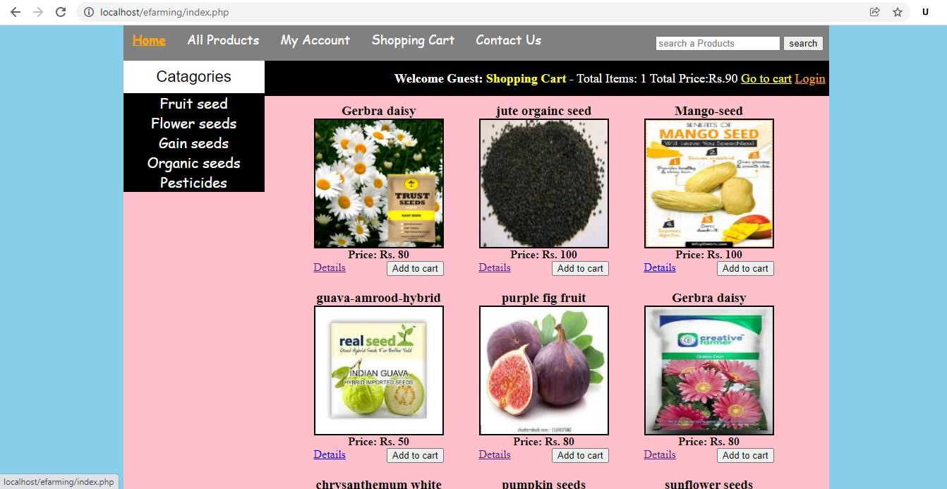

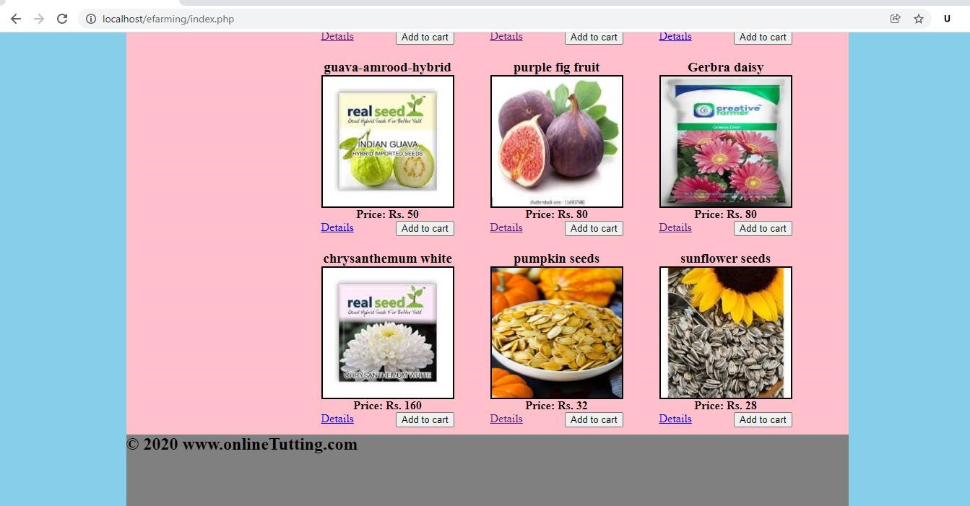

### 2) All Products

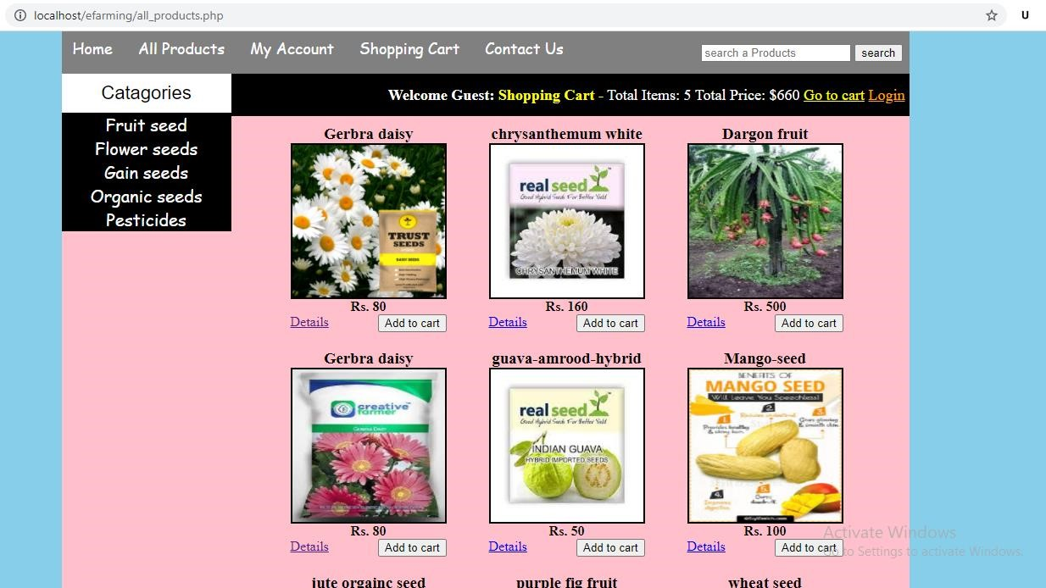

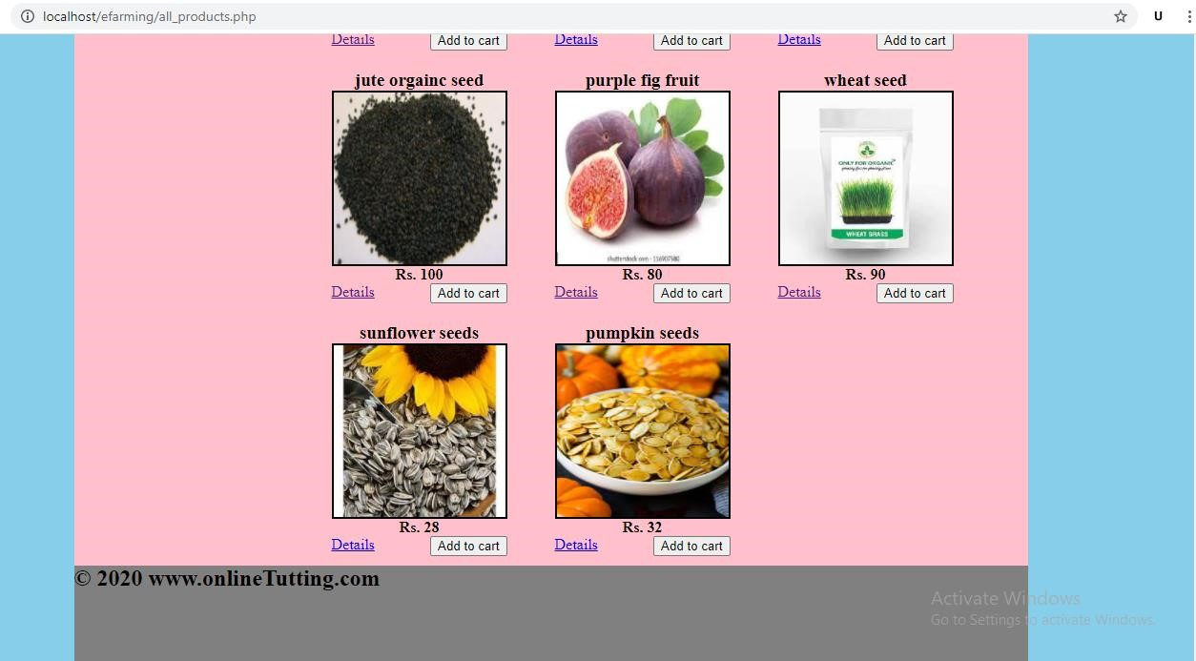

**3) Categories**

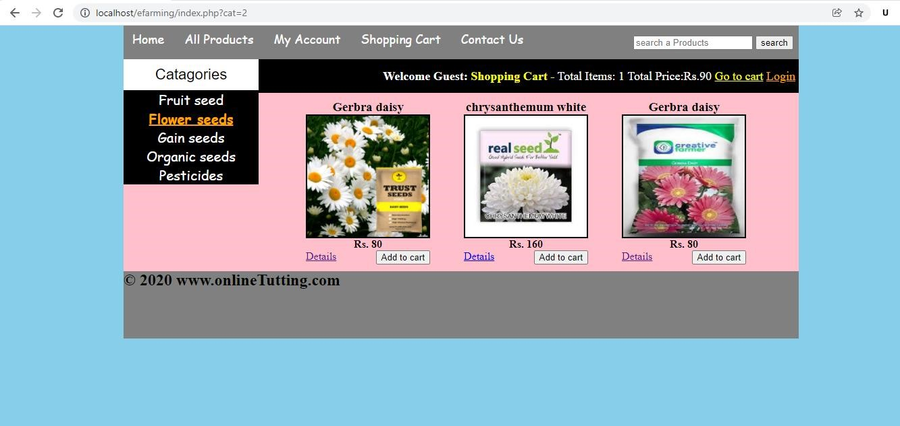

### 4) Product details

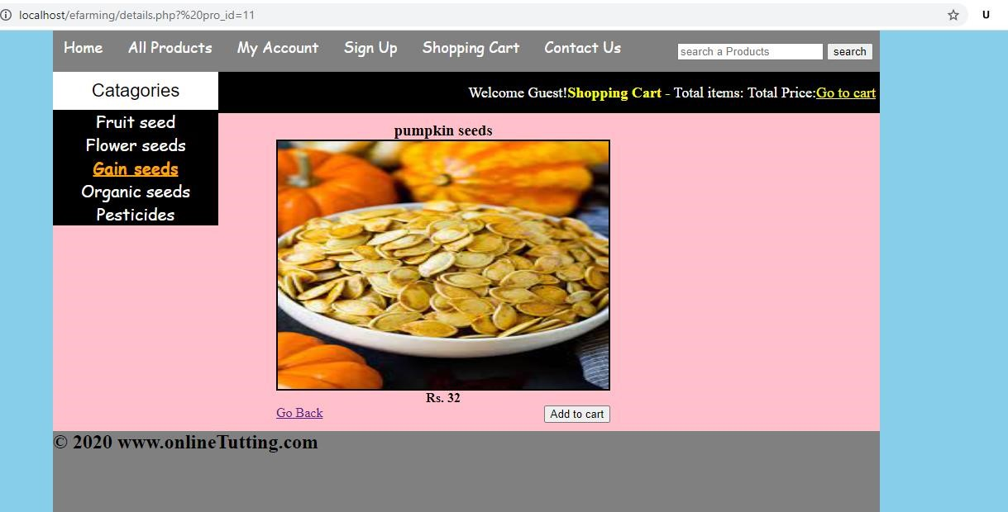

### 5) Customer registration

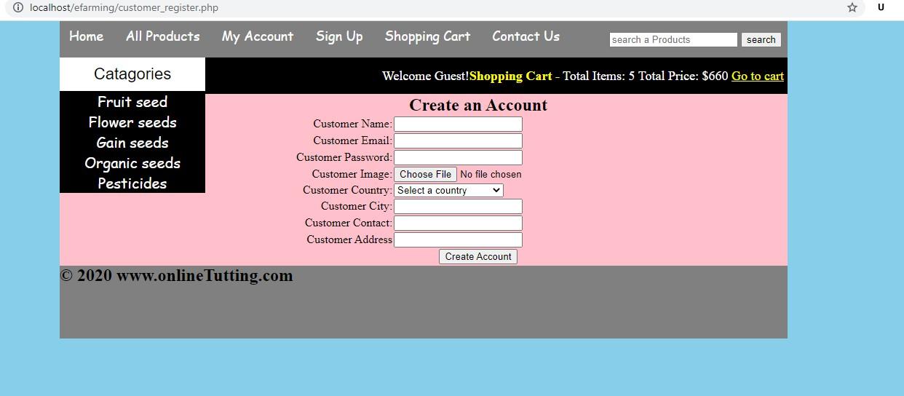

### 6) Customer login

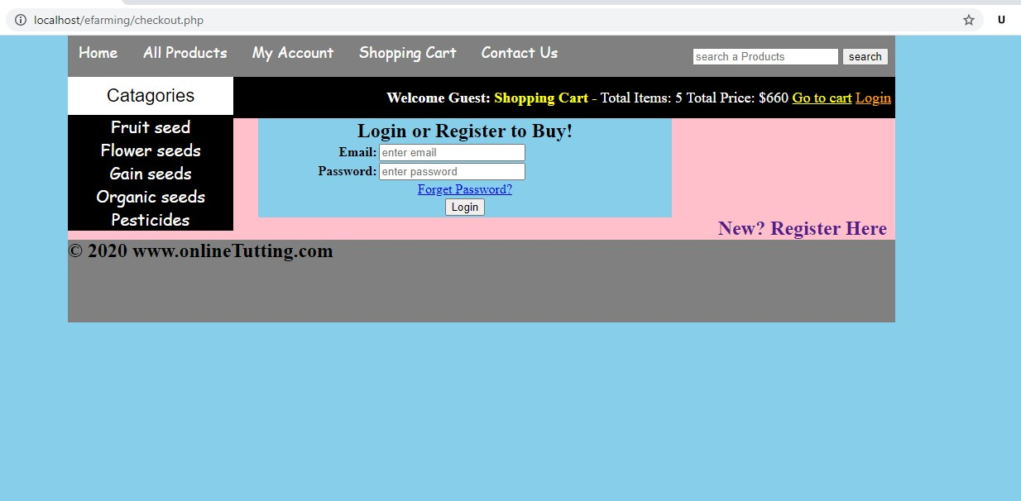

### 7) Cart item details

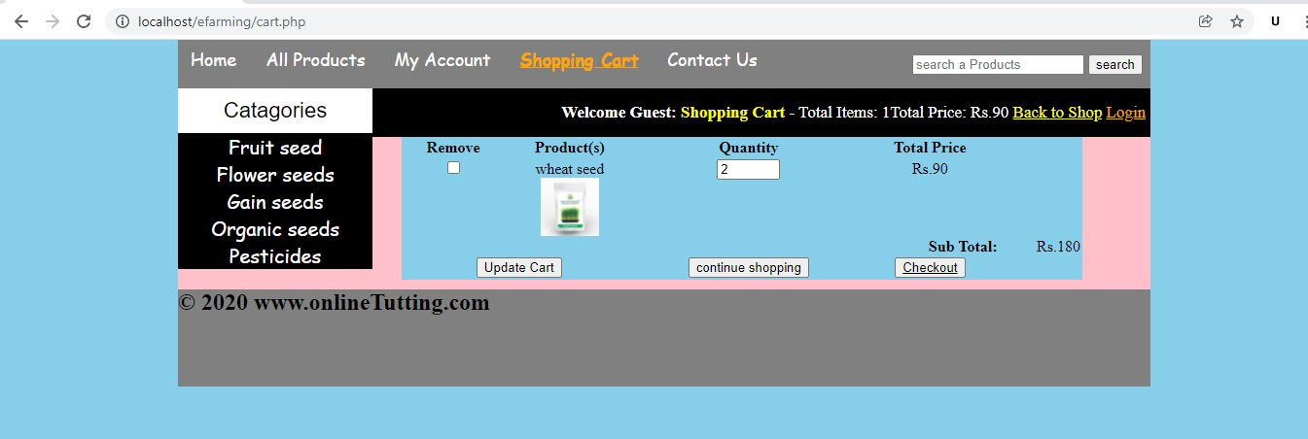

### 8) Payment screen

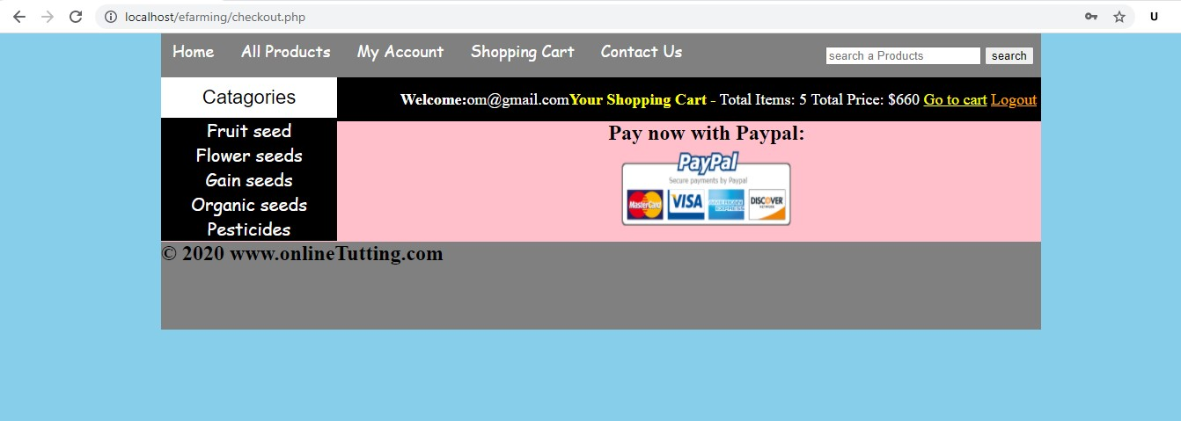

### 9) Customer dashboard

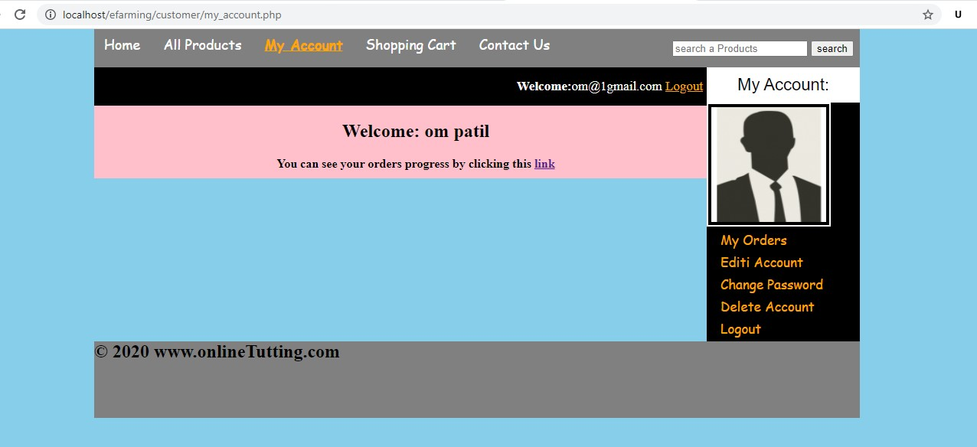

### 10) Contact us

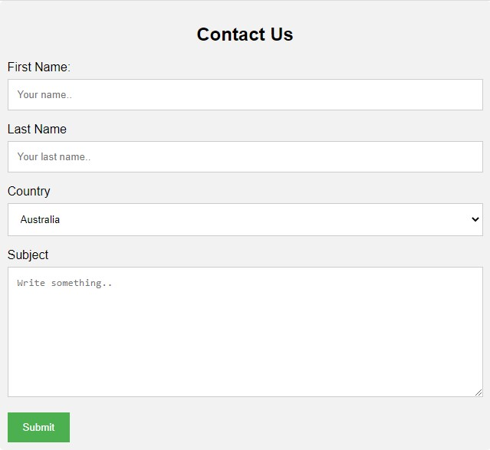

#### 11) Update account

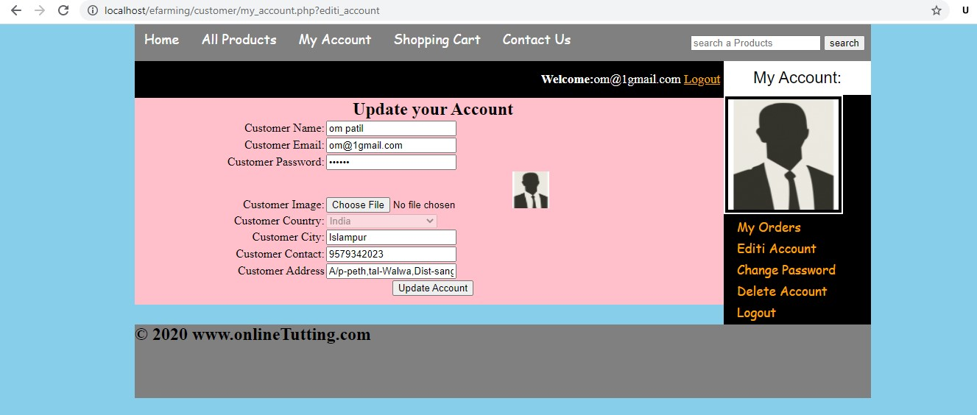

#### 12) Change password

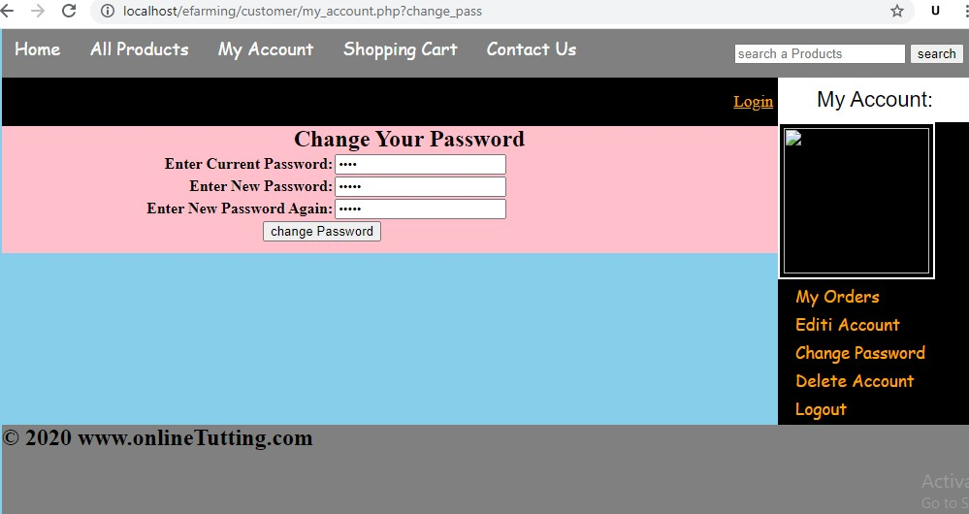

#### 13) Admin Login

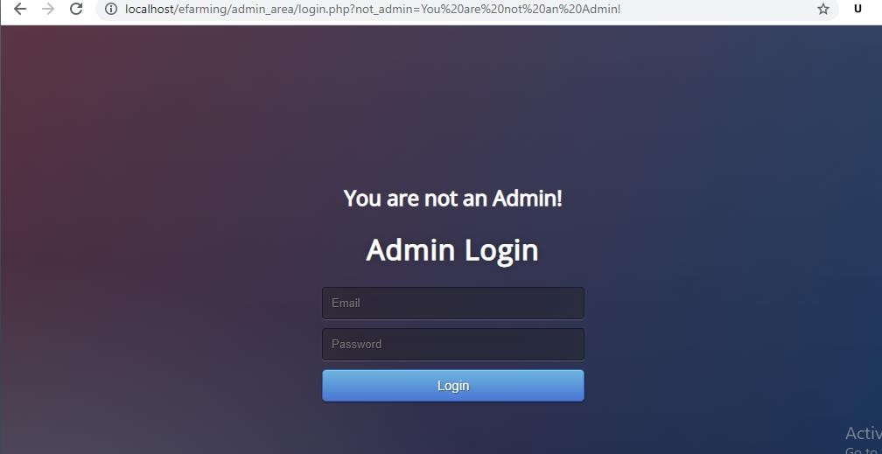

#### 14) Insert New Product

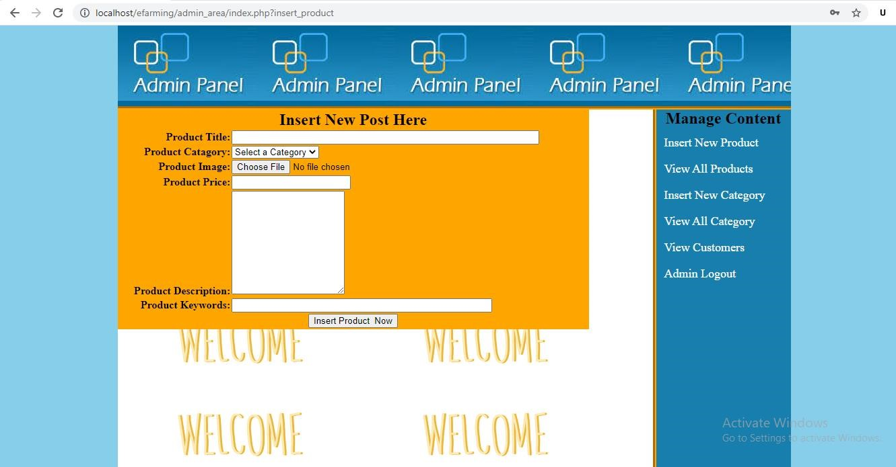

## DATABASE REPORT

### 1) Customer table

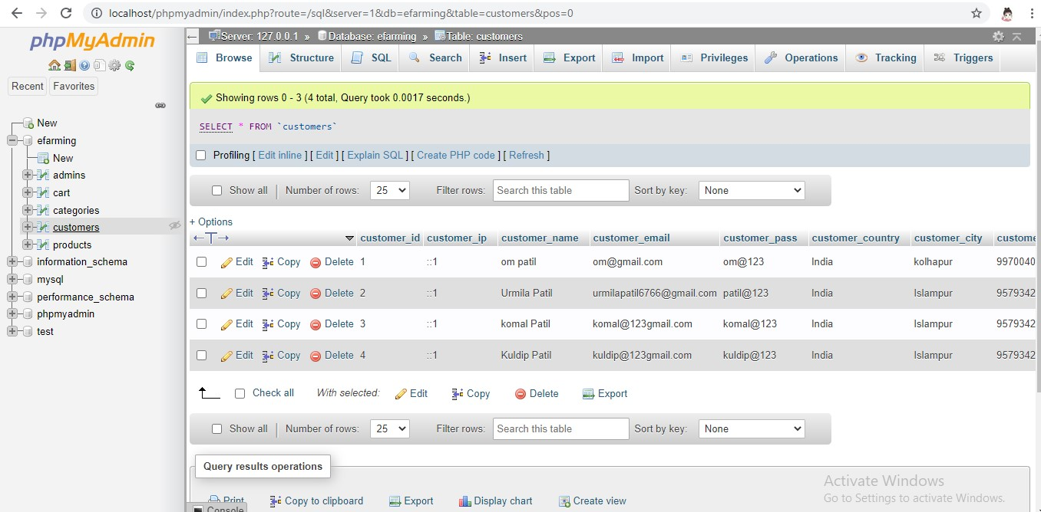

### 2) Products table

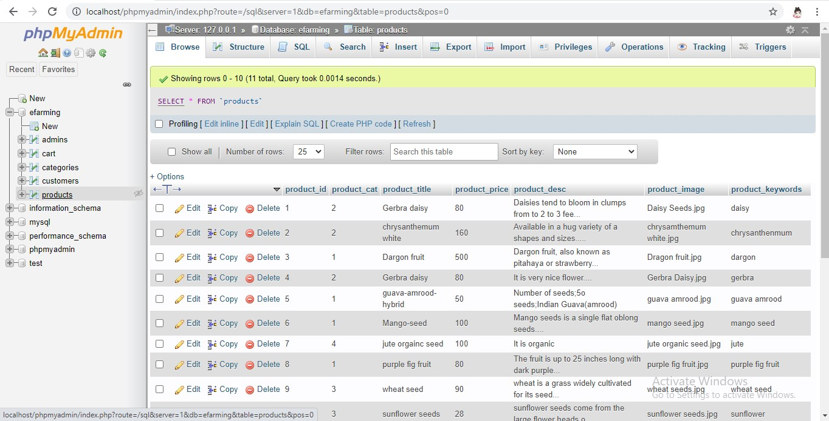

### 3) Categories table

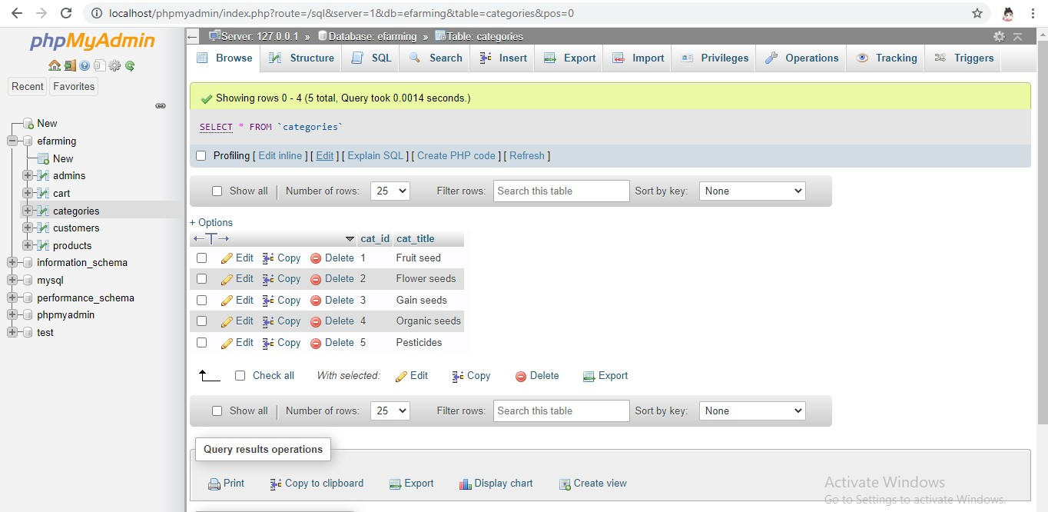

### 4) Cart table

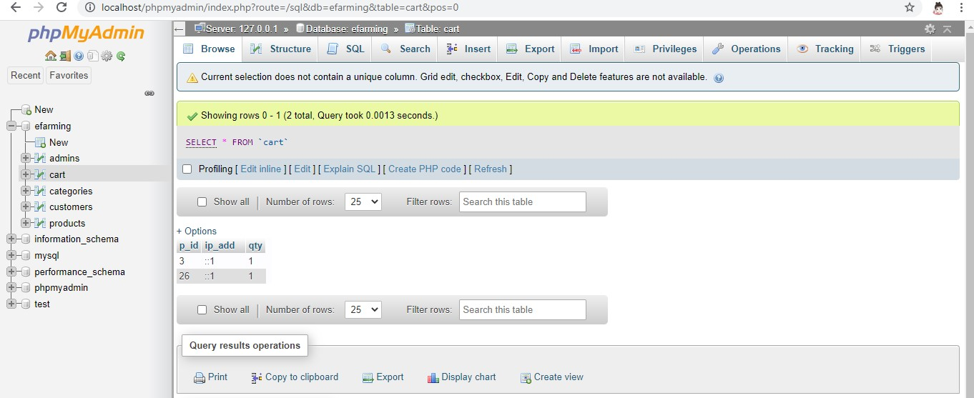

## 5) Admin table

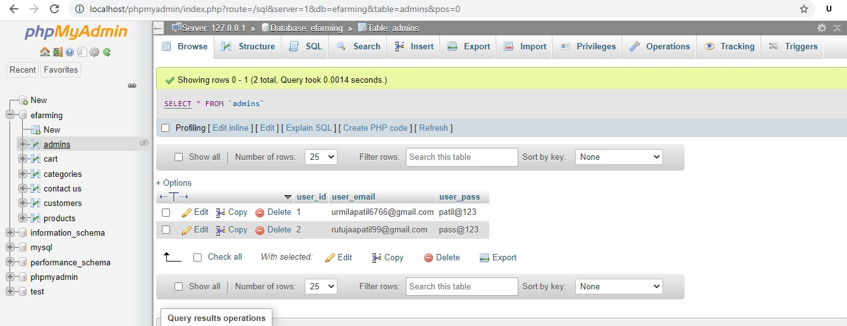

## REPORTS

### 1) All customers

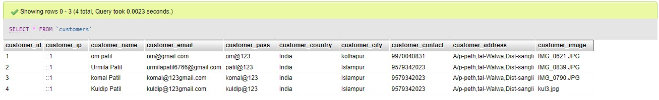

### 2) All products

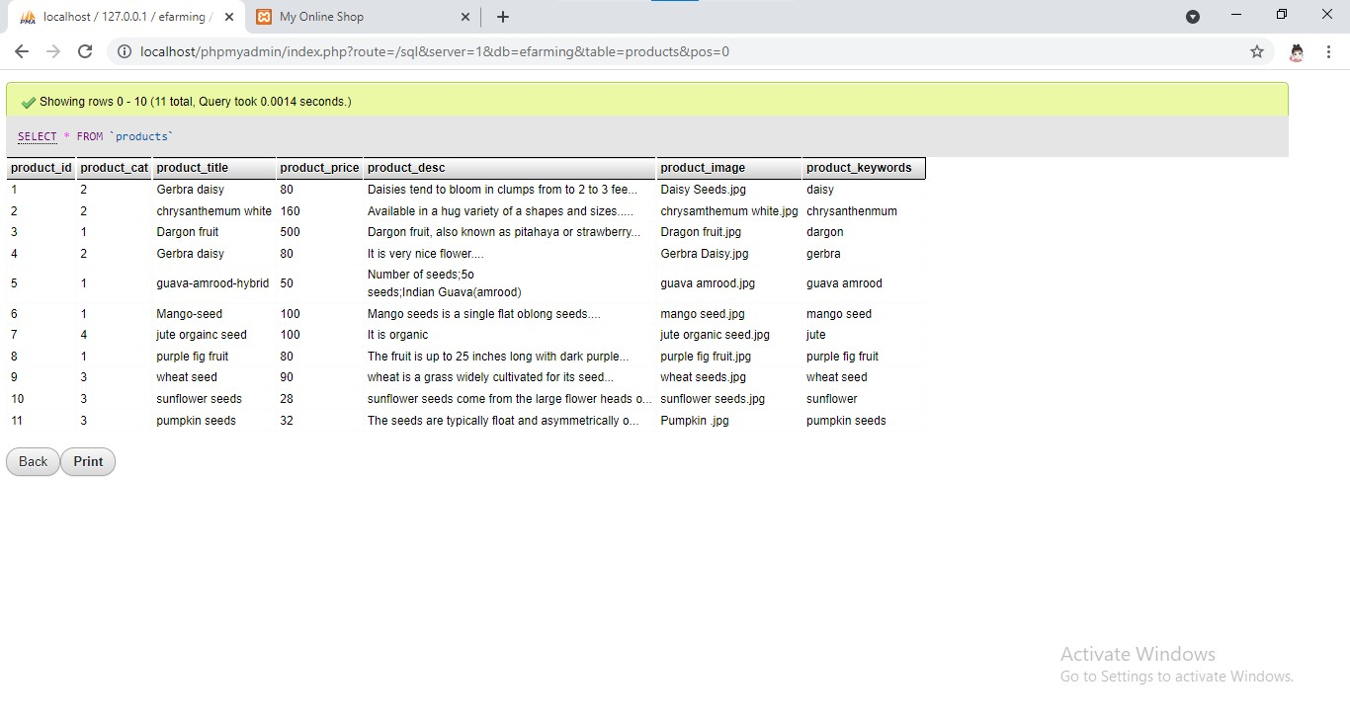

### 3) All categories

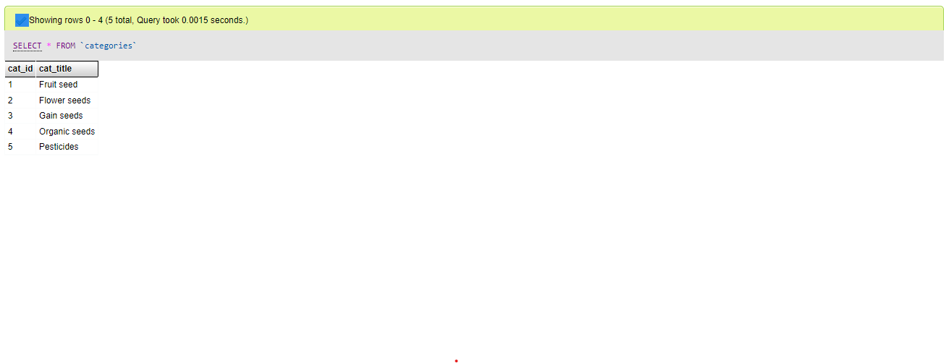

# FUTURE ENHANCEMENT

* We can add printer in future
* We can give more advance software for online E –Farming portal including more facilities
* We will host the platform on online servers to make it accessible worldwide
* Create the master and slave data base structure to reduce the overload of the database queries
* Implement the backup mechanism for taking backup of code base and database on regular basis on different servers
* E Farming can be implementing by using satellite. With help of satellite communication user can observe the climate conditions of the farm even by sitting at home. Based on the future security issues, security can be improved using emerging technologies.

# ADVANTAGES

1. Better marketing exposure and pricing.
2. Reduction of agriculture risks and enhanced income.
3. Farmers can directly sell their products to wholesaler so, they can get more profits.

# LIMITATIONS

1. It will take more time to the farmer. Even farmers can’t get actual profits.
2. Transactions are executed in offline mode , hence online data for product type, customers capture and modifications is not possible

# CONCLUSION

Finally, this system gives more benefits to the farmers. Without going to market they can sell their products by setting at home also. It acts as an interface to the farmer to do their work easily.

This project will be helpful for Farmers to know more about

market information; will act as unique interface of schemes and compensation through this they will be always in touch of new technique and trends of farming.

**Bibliography**

Site Referred

1. [www.google.com](http://www.google.com/)
2. [www.w3school.com](http://www.w3school.com/)
3. [www.youtube.com](http://www.youtube.com/)
4. [www.freeprojectz.com](http://www.freeprojectz.com/)